Experiment 1

Code: Myframe

import java.awt.\*;

class Myframe extends Frame {

Myframe() {

setSize(400, 400);

setVisible(true);

setLayout(null);

setTitle(" Frame 1");

Label l = new Label("Name :");

l.setBounds(30, 100, 80, 30);

add(l);

TextField t1 = new TextField();

t1.setBounds(120, 100, 250, 30);

add(t1);

Label l1 = new Label("Address :");

l1.setBounds(30, 150, 80, 30);

add(l1);

TextArea t2 = new TextArea();

t2.setBounds(120, 150, 250, 100);

add(t2);

Label l2 = new Label("Gender :");

l2.setBounds(30, 270, 80, 30);

add(l2);

CheckboxGroup g = new CheckboxGroup();

Checkbox male = new Checkbox("Male", g, true);

male.setBounds(130, 270, 50, 30);

add(male);

Checkbox female = new Checkbox("Female", g, false);

female.setBounds(185, 270, 65, 30);

add(female);

Label l3 = new Label("Department :");

l3.setBounds(30, 310, 80, 30);

add(l3);

Choice d = new Choice();

d.setBounds(130, 315, 250, 350);

d.add("computer Science And Enginnering");

d.add("Mechanical Enginnering");

d.add("Electrical Enginnering");

d.add("Electronic Enginnering");

d.add("Artificial Intelligence Enginnering");

add(d);

Label l4 = new Label("Hobbies:");

l4.setBounds(30, 350, 80, 30);

add(l4);

Checkbox Sports = new Checkbox("Sports");

Sports.setBounds(120, 350, 80, 30);

add(Sports);

Checkbox Reading = new Checkbox("Reading");

Reading.setBounds(120, 385, 80, 30);

add(Reading);

Checkbox Drama = new Checkbox("Drama");

Drama.setBounds(120, 420, 80, 30);

add(Drama);

Label lp = new Label("Programming Languages");

lp.setBounds(30, 500, 140, 30);

add(lp);

List list1 = new List(2, true);

list1.setBounds(180, 500, 150, 40);

list1.add("c#");

list1.add("c++");

list1.add("JavaScript");

list1.add("Python");

add(list1);

Button b1 = new Button("Save");

b1.setBounds(140, 600, 40, 30);

add(b1);

Button b2 = new Button("Clear");

b2.setBounds(200, 600, 40, 30);

add(b2);

Color c5 = new Color(255, 255, 255);

b2.setForeground(c5);

Color c2 = new Color(255, 215, 0);

b1.setBackground(c2);

Color c3 = new Color(255, 0, 0);

b2.setBackground(c3);

Color c1 = new Color(50, 150, 50);

setBackground(c1);

}

public static void main(String args[]) {

Myframe m = new Myframe();

}

}

Output:

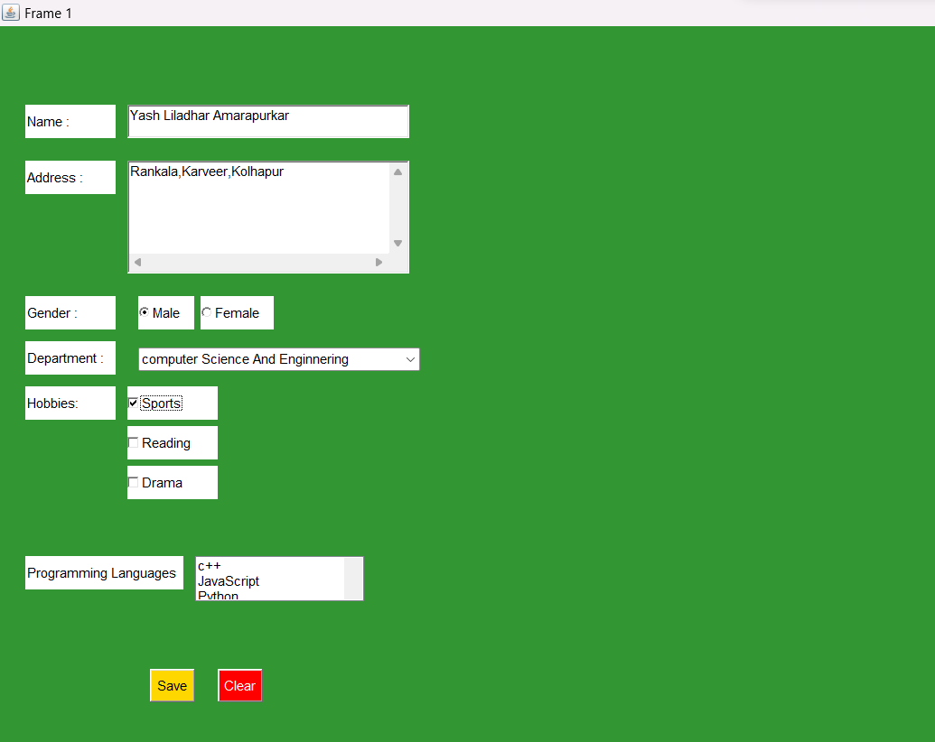

Code: Menubar

import java.awt.\*;

class Demo extends Frame

{

Demo()

{

setLayout(null);

MenuBar mb=new MenuBar();

Menu mn1= new Menu("File");

MenuItem m1=new MenuItem("New");

MenuItem m2=new MenuItem("Open");

MenuItem m3=new MenuItem("Save");

Menu mn2= new Menu("Edit");

MenuItem m4=new MenuItem("Copy");

MenuItem m5=new MenuItem("Cut");

MenuItem m6=new MenuItem("Paste");

Menu mn3= new Menu("View");

Menu mn4=new Menu("Zoom");

MenuItem m8=new MenuItem("Zoon In");

MenuItem m9=new MenuItem("Zoon Out");

MenuItem mn5=new MenuItem("Status Bar");

mn1.add(m1);

mn1.add(m2);

mn1.add(m3);

mn2.add(m4);

mn2.add(m5);

mn2.add(m6);

mn4.add(m8);

mn4.add(m9);

mn3.add(mn4);

mn3.add(mn5);

mb.add(mn1);

mb.add(mn2);

mb.add(mn3);

setMenuBar(mb);

setSize(500,500);

setVisible(true);

setTitle("Exp");

}

public static void main(String args[])

{

Demo d=new Demo();

}

}

Output:

